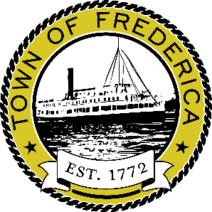
FREDERICA BOARD OF ADJUSTMENTS MEETING
FREDERICA TOWN HALL
2 W. DAVID STREET
THURSDAY, FEBRUARY 5, 2026 AT 6:30PM

*There may be a quorum of Town Council Members present at this meeting.

AGENDA

Call to Order
Pledge of Allegiance
Roll Call
Variance Application
7-Eleven Signs (5-08-14100-01-0800-00001)
Adjournment

Note: Agenda items listed may not be considered in sequence. This agenda is subject to change to include
additional items including Executive Sessions and/or the deletion of items including Executive Sessions which
may arise at the time of the meeting. A quorum of Planning and Zoning may also be present at this meeting.
ALL Open Floor discussions are limited to 3 minutes per person. NO EXCEPTIONS.
Posted 1/20/2026

